Annotated Maps

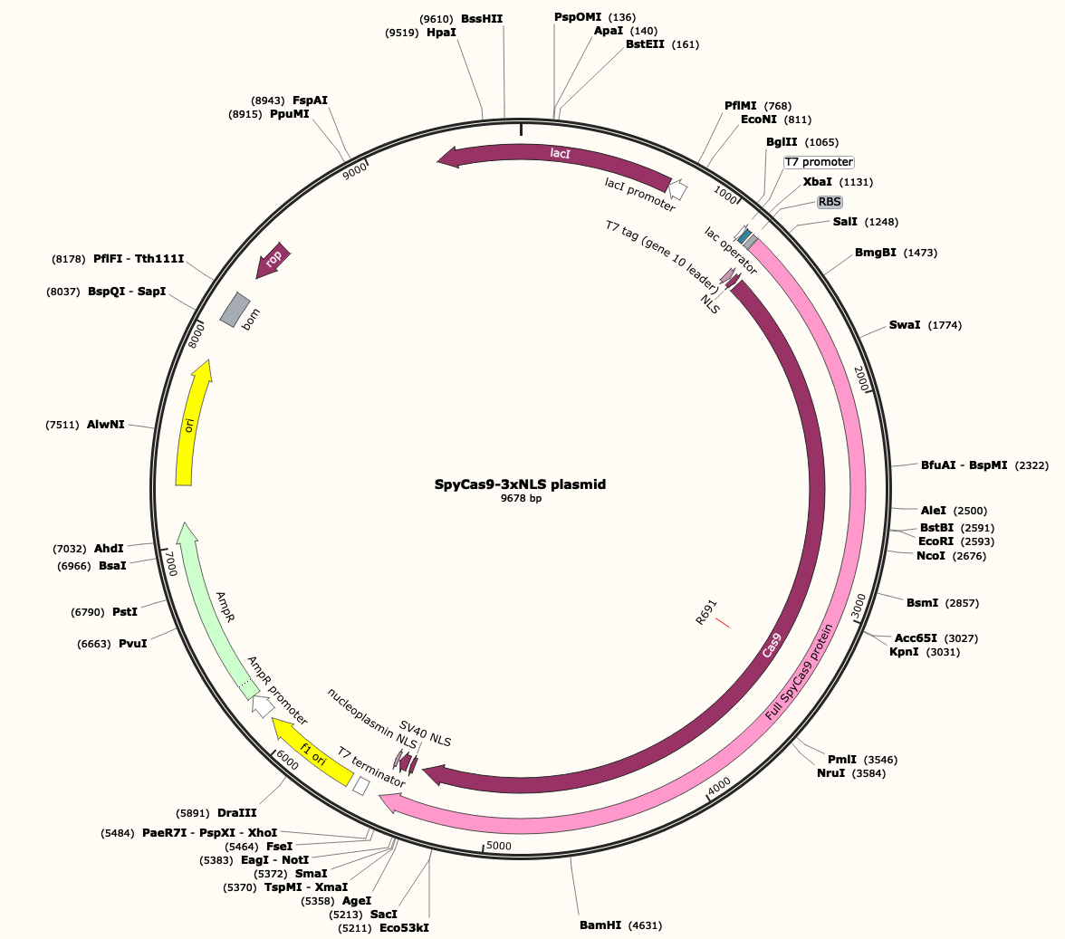
SpyCas9-3xNLS plasmid:

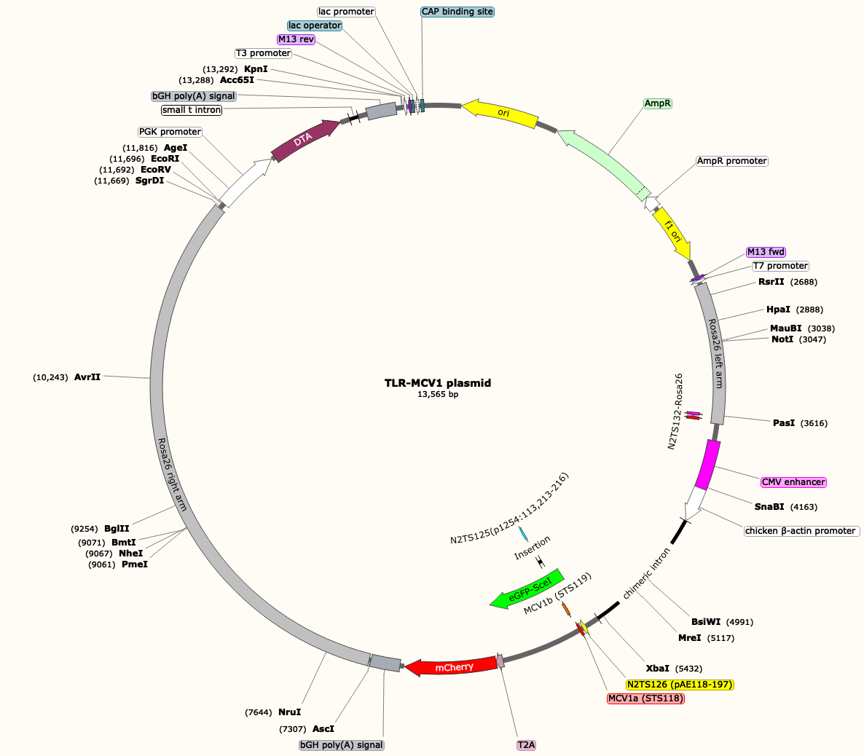

TLR-MCV1 plasmid:

TLR-MCV1 Locus in Rosa26:
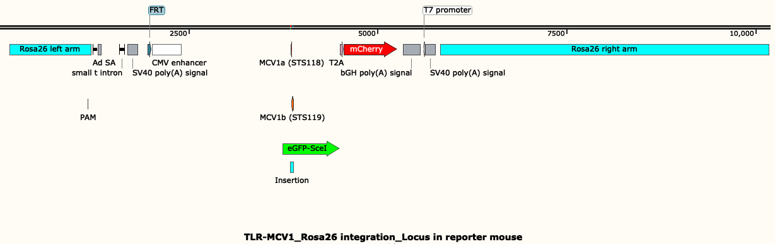

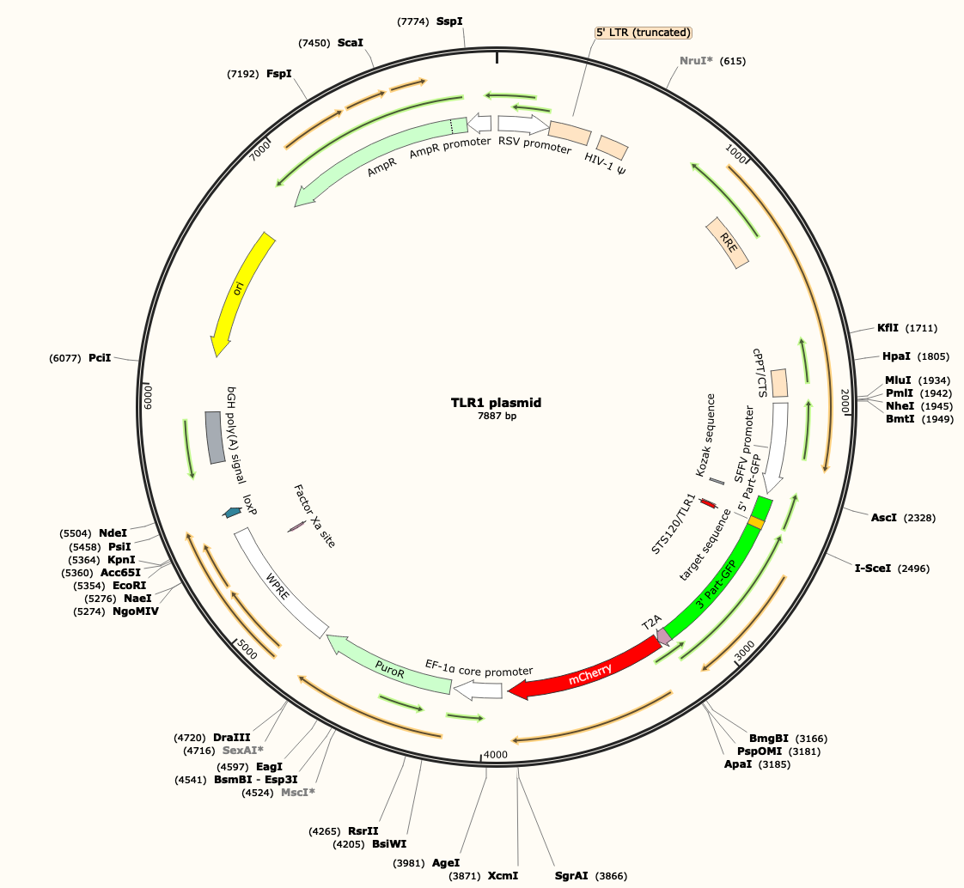
TLR1 plasmid:

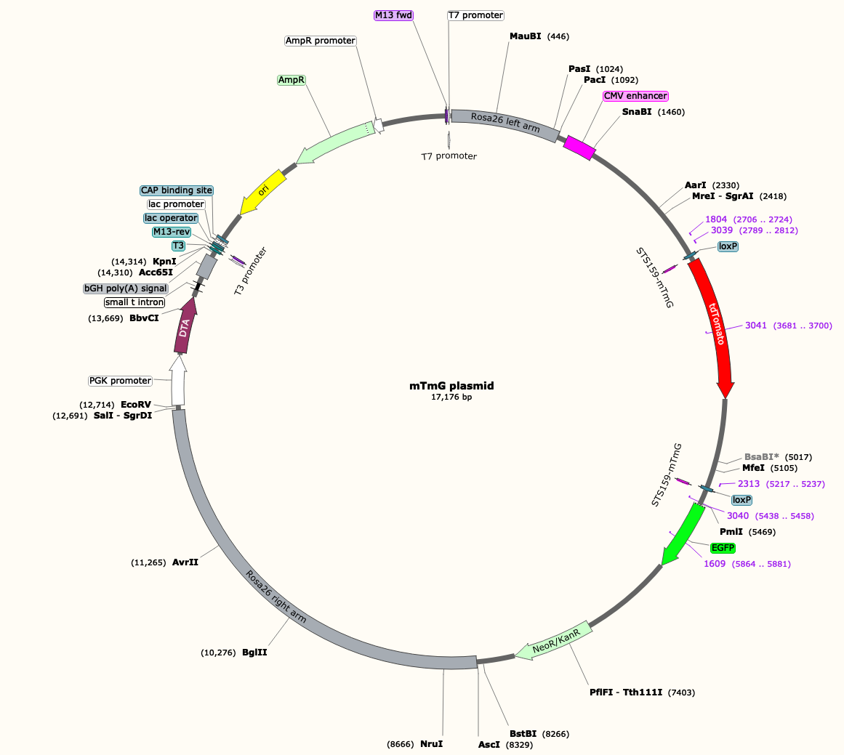

mTmG plasmid:

Pcsk9 Locus:

