Finalized BCM-Rice SATC Validation Plan

Deverman Delivery Team: Novel AAVs Engineered for Efficient and Noninvasive Cross-Species Gene Editing Throughout the Central Nervous System

- Project summary and overall goal (provided by the Delivery Team)

Our delivery system is a novel peptide-modified AAV identified by high-throughput screening. Our in vivo validation data indicate that this virus can be used to efficiently deliver reporter transgenes to neurons astrocytes, or CNS endothelial cells in the CNS of C57BL/6 mice and BALB/cJ mice.

- Delivery system details

- Delivery vehicle: novel peptide-modified AAV. The virus will be produced by the Deverman group and purified by either iodixanol density gradient separation or by affinity column chromatography (HPLC) followed by density gradient ultracentrifugation to remove empty capsids.

- Editing system to be delivered: DNA encoded SauCas9 with appropriate DNA encoded sgRNA(s).

- Dual vector for Ai9: hSyn/CMV/GFAP-SaCas9-pA + hSyn/CMV/GFAP-GFP-U6-gRNA-L1-U6-gRNA-R2

- Delivery controls to be employed: The above system but with a control GFP vector not harboring sgRNA sequences will be used as an editing negative control (hSyn/CMV/GFAP-GFP-U6x2).

- Delivery vehicle storage: The material should be stored at -80C until the day of administration. Once thawed, if the test material is kept sterile and not diluted or transferred to a new tube, it is expected to retain potency at -4C for several weeks. The material should not be refrozen for reuse. The recombinant viruses will be delivered as single-use aliquots. Any unused test material should be stored at -80C until results have been obtained to allow us to reassess titers or vector function if necessary.

- Delivery vehicle known adverse effects: At the doses being used, adverse effects beyond a limited glial response in areas of the brain with high levels of SaCas9 expression are not expected. Neurological symptoms or systemic toxicities in pilot studies with GFP have not been observed, but more careful studies with longer termed SaCas9 expression have not been performed.

- Target tissue: The on-target tissue is the brain. However, it is not part of our milestones to demonstrate targeted brain delivery. Therefore, other organs are not necessarily considered off-target.

- Reporter animal details

- Reporter line to be utilized: Ai9

- sgRNA target sequences to be utilized:

L1 gRNA: 5’Cctctagagtcgcagatcctc (TAGAGT)- SaCas9 “A” left guide
R2 gRNA: 5’cgacctgcagcccaagctaga (TCGAAT)

- Study design:

- Route of Administration: retro-orbital sinus injections (IV). BCM IACUC approval of the procedure is in place and SATC staff are practicing the technique to become proficient.

- Dosage and volume to be administered: 5x10¹³ vg/kg in a volume of 50-100 μl.

Shipment 1 contents
 | ddPCR probe WPRE | ddPCR probe ITR | Average vg/mL | Total vg/aliquot (100 uL) | Total tubes shipped
BI28:hSYN1-Cas9-WPRE-pA | 7.43E+12 | 1.08E+13 | 9.11E+12 | 9.11E+11 | 16*
BI28:hSYN1-NLS-GFP-U6x2 | 1.45E+13 | 2.07E+13 | 1.76E+13 | 1.76E+12 | 6*
BI28:hSYN1-NLS-GFP-L1/R2 | 1.57E+13 | 2.31E+13 | 1.94E+13 | 1.94E+12 | 5*

Dilutions before injections – these calculations assume a 20g mouse given a dose of 5E11 of each vector (1E12 total dose)
 |  | 1X mixture |  | 7X mixture |  | Tubes required
Study Arm 1a (experimental group) | Dose | Virus (uL) | PBS (uL) | Virus (uL) | PBS (uL)
BI28:hSYN-Cas9-WPRE-pA | 5.00E+11 | 54.9 | 19.3 | 384 | 135 | 4
BI28:hSYN-NLS-GFP-L1/R2 | 5.00E+11 | 25.8 |  | 181 | 0 | 2
 |  | 1X mixture |  | 7X mixture |  | Tubes
Study Arm 1b (control group) | Dose | Virus (uL) | PBS (uL) | Virus (uL) | PBS (uL)
BI28:hSYN-Cas9-WPRE-pA | 5.00E+11 | 54.9 | 16.6 | 384 | 117 | 4
BI28:hSYN-NLS-GFP-U6x2 | 5.00E+11 | 28.4 |  | 199 | 0 | 2

Chart of final mix injection volume based on weight to achieve a total dose of 5E13 vg/kg
Animal Weight (g) | Injection volume (uL)
15 | 75
16 | 80
17 | 85
18 | 90
19 | 95
20 | 100
21 | 105
22 | 110
23 | 115
24 | 120
25 | 125

* Note: we are not supplying sufficient aliquots to use 1 tube per mouse. We are shipping adequate virus, but only if aliquots are pooled and animals in are injected in 2-3 groups of ~6-9 animals each.

- Age of administration: 6-8 weeks.

- Study time course: Mice will be euthanized at 4 weeks after delivery system administration for tissue collection.

- Experimental group: One group of 12 Ai9 animals (6 males and 6 females) will be injected with a dual AAV vector system expressing SauCas9 from one vector and the appropriate sgRNAs and NLS-GFP from another. Two capsid types will be tested.

- Control groups: One group of 6 Ai9 animals (3 males and 3 females) will be injected with a dual AAV vector system expressing SauCas9 from one vector and NLS-GFP from another. The BCM-Rice SATC will provide a group of 2 animals (1 males and 1 females) RO injected with saline as a control group for normal tissue histology, a negative control group for fluorescent reporter imaging, and a wild-type control for molecular analyses.

- Measurements during study: Body weights will be noted at the time of delivery system application and euthanasia.

- Study failure: If editing fails to be detected in the target tissue or if at least 4 male and 4 females from an experimental group do not complete the study, the group may be repeated with modifications one additional time
Summary of study design
Study Arm | Animal Model | Delivery System | Route of Admin | Age of admin | Concentration and volume | Animal Numbers | Study Time Course | Exp or Cntrl Group
1a | Ai9 | AAV-hSYN1-SaCas9; AAV-hSYN1-GFP-U6-L1/R2-gRNA  (capsid 1) | IV (RO inj) | 6-8 wks | 2.5x10¹³ vg/kg each virus | 12  (6 male, 6 female) | 4 wks | Experimental
1b | Ai9 | AAV-hSYN1-SaCas9; AAV-hSYN1-GFP-U6-2x-no gRNA  (capsid 1) | IV (RO inj) | 6-8 wks | 2.5x10¹³ vg/kg each virus | 6  (3 male, 3 female) | 4 wks | Pos/Deliv Control  GFP, adverse effects control
2a | Ai9 | AAV-CMV/GFAP-SaCas9; AAV-CMV/GFAP-GFP-U6-L1/R2-gRNA  (capsid 2) | IV (RO inj) | 8 wks | 5x10¹² - 5x10¹³ vg/kg (TBD) | 12  (6 male, 6 female) | 4 wks | Experimental
2b | Ai9 | AAV-CMV/GFAP-SaCas9; AAV-CMV/GFAP-GFP-U6-2x-no gRNA  (capsid 2) | IV (RO inj) | 8 wks | 5x10¹² - 5x10¹³ vg/kg (TBD) | 6  (3 male, 3 female) | 4 wks | Pos/Deliv Control  GFP, adverse effects control
3 | Ai9 | saline | IV (RO inj) | 8 wks | <200 µl | 2  (1 male, 1 female) | 4 wks | Neg Control

- Tissue collection and analysis:

  - Tissues to be collected:
White adipose tissue (subcutaneous and perigonadal collected and imaged separately) | Pancreas | Muscle (gastrocnemius, soleus, TA, EDL, intercostal collected and imaged separately)
Epididymis or Uterus | Heart | Brown adipose tissue
Testes or Ovary | Lung | Brain* (see below for dissection protocol)
Liver | Diaphragm | Eye
Kidney | Stomach
Spleen | Intestine (duodenum, jejunum, ileum, colon collected and imaged separately)

Four weeks after administration, tissues will be collected and processed for imaging and molecular analyses as described in the attached protocol.
* Consistent sagittal brain sections (1 mm; 5 per hemisphere) will be prepared on fresh tissue using the following brain matrix: http://www.zivicinstruments.com/brain-slicer-matrix-mouse-adult-1mm-sagittal-brain-slices-section-stainless-steel.html. Sagittal sections from the left side of the brain will be individually processed for molecular analyses; the right hemisphere will be processed for imaging. Tissues for imaging will be fixed, oriented and mounted, frozen sectioned to 14 μM, and imaged following our standard protocol.
- Reporter imaging and analysis:
  - Each tissue will be PFA fixed, frozen, sectioned, stained with DAPI, and imaged, as described in the attached protocol. Right hemisphere brain sagittal sections (1mm; up to 10 sections) will be processed for sectioning as described above. Three non-consecutive sections will be imaged from each tissue (each sagittal section for the brain) as described in the attached protocol.
  - Data reported:
- For all tissues in Study Arms 1 and 2 except for the brain (experimental and positive control group): the extent of fluorescence will be quantified as fluorescent (tdTomato from the reporter or virus delivered NLS-GFP) cells per DAPI-stained nucleus. The total counted, positive counted, and percentage positive cells for each animal will be reported for each animal.
- For the brain in Study Arms 1 and 2: for each sagittal section imaged, the extent of fluorescence will be quantified as fluorescent (tdTomato from the reporter or virus delivered NLS-GFP) cells per DAPI-stained nucleus. For the brain, fluorescent cells per major brain region (e.g. cerebral cortex, thalamus) will be quantified for each animal. As shown in the figure below (provided by the Delivery Team), NLS-GFP expression from AAV-BI28, the current lead vector, after RO administration is highlighted in the cerebral cortex (blue outlined area) and thalamus (red outlined area).

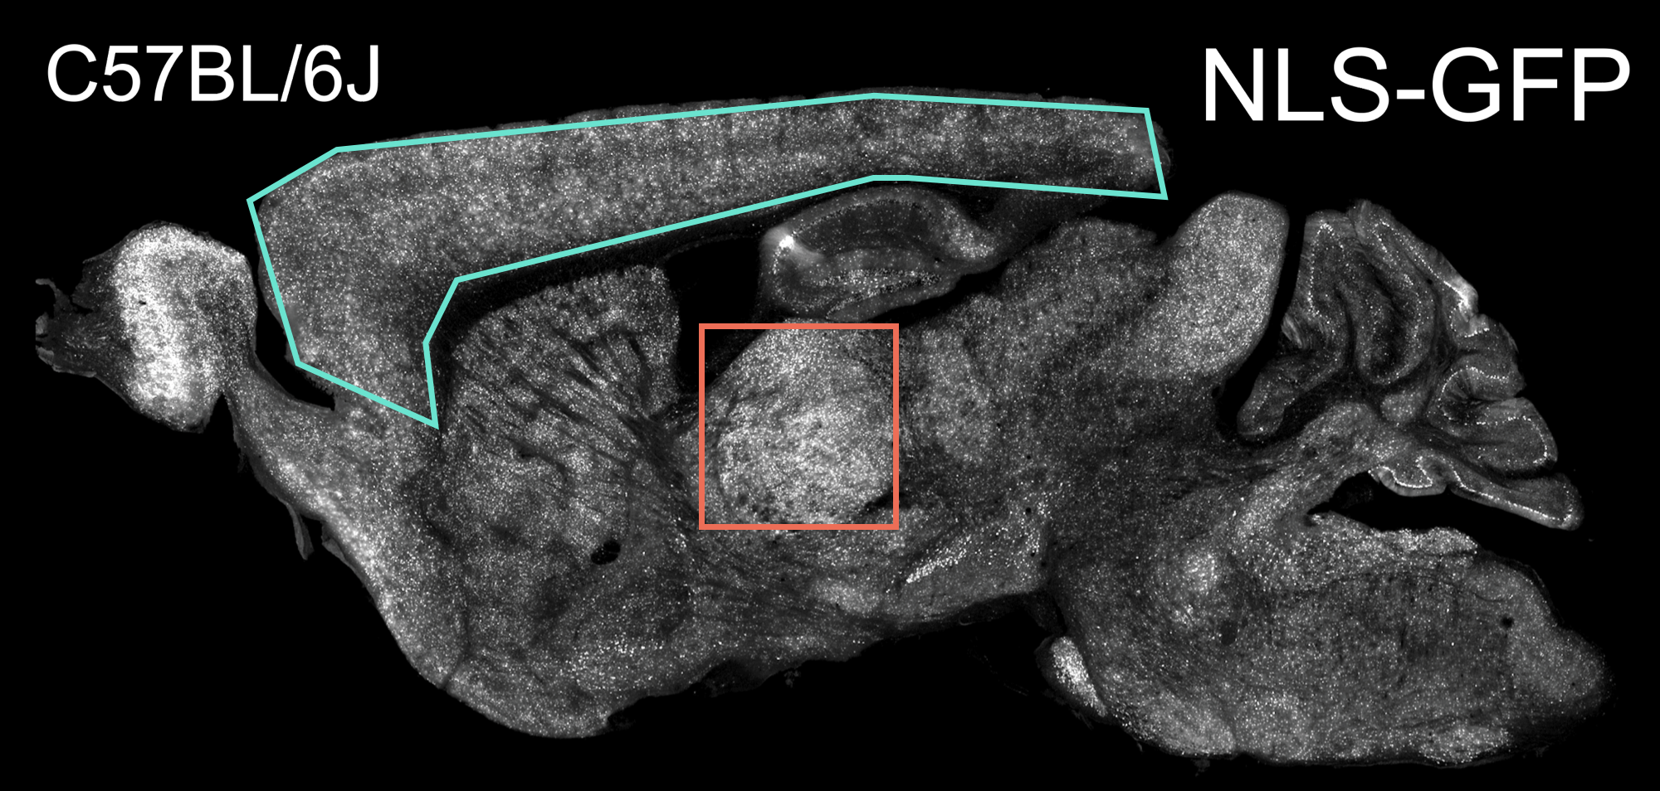
- For Study Arm 1 and 2, the average percent positive cells counted in female, male, and sexes combined will be reported.
- For Study Arm 1 and 2, patterns of fluorescence observed in each tissue will be described (e.g. positive cells localized to areas around blood vessels or specific cell types that can be determined).
- Tissues from Study Arm 3 animals will be used as imaging negative controls.
- All collected data, including images, will be transmitted to the DCC.
- To compare detection across groups, the delivery team will send a test slide to the Baylor SATC that has been assessed here for transduction (GFP) and tdTomato expression (editing/recombination).
- If the alternative study arm 1 strategy is employed, we can image and quantify tdTomato, GFP, and dual-positive cells in tissues.

- Health evaluation and histology: Animals in each experimental and control group will be monitored for observable changes in health. Additionally, for each animal in each group, study start and end body weights and the weights of spleens, livers and the tissue of interest (brain) will be reported as an indicator of overall health and potential inflammation response. For each animal in each group, three non-consecutive sections of spleen, liver, and target tissues (brain) will be processed for H&E staining as described in the attached protocol, and scores of immunogenicity or other morphological anomalies provided.

- Molecular Analyses: For experimental groups, genomic DNA extracted from frozen samples of the tissue if interest (brain - sagittal sections from the left hemisphere) will be analyzed by ddPCR to confirm bulk tissue genome editing frequency at the reporter allele. In addition, targeted deep sequencing will be performed to detect off-target CRISPR-mediated editing events at the top 10 predicted sites predicted by the COSMID algorithm. Saline injected animals will function as the control group for these analyses.
  - Data reported:
    - On-target editing: edited allele frequency detected in the bulk tissue.
    - Off-target editing: locations and sequence of off-target events and allele (read) frequency in bulk tissue.

- Special requests
Tissue blocks and slides will be saved and provided to the Delivery Team for co-immunolabeling with NeuN or S100b immunostaining to assess editing in specific cell populations in the brain.

- Timeline

  - Testing of Delivery Systems will commence by 7/31/2020 and will be scheduled in coordination with the other Delivery Teams assigned to the BCM-SATC.

  - Data (excluding off-target analysis, which is not required for Delivery Team grant transition reports) will be provided by 4/01/2021. Off-target analysis reports should be available by 7/31/2021.

8. Shipment address:
Attn: William Lagor
Baylor College of Medicine
Room T428
One Baylor Plaza
Houston, TX 77030
ph. 813-870-2141

Baylor/Rice SATC tissue preparation and imaging standard protocols

Tissue Preparation for Imaging

1) After euthanasia and removal of the white fat pads and the reproductive organs, the inferior vena cava will be slit below the liver. The left ventricle will be punctured, and the animal injected with 20 ml of cold PBS through the bloodstream.

2) Remove the organ or tissue sample from the euthanized mouse and remove extraneous material.

3) Remove a small section and freeze immediately in liquid nitrogen for molecular analyses.

4) Place organ in 10 ml of freshly-prepared 4% paraformaldehyde in a 20 ml vial.

5) Incubate for 20 - 24 hours at 4˚C with gentle agitation.

6) Remove paraformaldehyde solution and replace with 30% sucrose in PBS.

7) Incubate for 20 - 24 hours at 4˚C with gentle agitation.

8) Embed tissues in OCT, marking orientation for sectioning.

9) Freeze at -80˚C.

Sectioning and Imaging

1) Section frozen tissue blocks at 14 microns, and place three non-consecutive sections on one slide.

3) For each tissue, one slide will be mounted with DAPI stain and imaged on a Zeiss Axio Scan.Z1 scanner, using the 20X objective and Cy5 (for tdTomato) and DAPI fluorescent filters.

4) For the liver, spleen, and target tissue of interest, one slide will be prepared for H&E staining to assess histopathology and immune infiltration.

Analysis

1) Examine images using ZEN software. Note:
a) Presence or absence of tdTomato signal and other fluorescent signals
b) Structural integrity of organ, based on DAPI staining
c) attempt to identify type of cell expressing tdTomato or other fluorescent signals
d) attempt to identify a pattern of tdTomato expression or other fluorescent signals

2) Quantify extent of tdTomato fluorescence using ImageJ
a) Count nuclei using Threshold/Binarize/Watershed algorithms
b) Count fluorescent positive cells, either manually, or using Threshold/Binarize/Watershed algorithms
c) Report data as percentage of positive cells per nuclei

