Finalized BCM-Rice SATC Validation Plan

Gao Delivery Team: Develop Combinatorial Non-Viral and Viral CRISPR Delivery for Lung Diseases

- Project summary and overall goal (provided by the Delivery Team)

We will test AAV-mediated delivery system for airway epithelial cells. In vivo validation will be performed in single-guide Ai9 mice with a target goal of ~10% Tomato+ lung airway cells.

- Delivery system details

- Delivery vehicle: AAV5 prepared at UMass.

- Editing system to be delivered: DNA encoded SpyCas9 and SauCas9 with an appropriate DNA encoded sgRNA.

- Delivery controls to be employed: DNA encoded Cre-EGFP will be used as a delivery control for toxicity and inflammation, and as positive control for imaging.

- Delivery vehicle storage: Vectors will be provided at working concentrations and stored at -80C. To avoid repeated freeze-thaw cycles, aliquots of 150μl will be provided for administration to 3 mice each (40μl injection per mouse).

- Delivery vehicle known adverse effects: No known adverse effects of vector administration were identified by the Delivery Team.

- Target tissue: lung airway epithelium

- Reporter animal details

- Reporter line to be utilized: The single-guide SauCas9/SpyCas9 Ai9 allele produced by BCM will be employed. One SauCas9 or SpyCas9 guide can activate tdTomato expression. Cre-mediated activation of tdTomato can be used as a delivery system positive control.
- sgRNA target sequences to be utilized:
  - SauCas9 delivery: 5’ ACGAAGTTATATTAAGGGTT (CCGGAT)
  - SpyCas9 delivery: 5’ gtatgctatacgaagttatt(agg)

- Study design:

- Route of Administration: Intratracheal injections via catheter. Details on equipment, supplies, and surgical procedures have been provided by the Delivery Team and are attached. The BCM Center of Comparative Medicine (CCM) will train relevant personnel on the surgical procedures. BCM IACUC approval is pending and issues are not anticipated. The Gao Delivery Team is willing to send personnel to provide additional SATC staff training if needed.

- Dosage and volume to be administered: For each AAV, 6e11 vg per mouse in a volume of 40μl.

- Age of administration: 8 weeks.

- Study time course: Mice will be euthanized at 4 weeks after delivery system administration for tissue collection.

- Experimental groups: One group of 12 animals (6 males and 6 females) will be injected with a pair of AAV vectors expressing SpyCas9 and the appropriate sgRNA and GFP. One group of 12 animals (6 males and 6 females) will be injected with an AAV vector expressing SauCas9 and the appropriate sgRNA.

- Control groups: One group of 4 animals (2 males and 2 females) will be injected with an AAV vectors expressing Cre-EGFP. The BCM-Rice SATC will provide a group of 4 animals (2 males and 2 females) tail vein injected with saline as a control group for normal tissue histology and a negative control group for fluorescent reporter imaging.

- Measurements during study: Body weights will be noted at the time of delivery system application and euthanasia.

- Study failure: If editing fails to be detected in the target tissue or if at least 4 male and 4 females from an experimental group do not complete the study, the group may be repeated with modifications one additional time.

Summary of study design
Study Arm | Animal Model | Delivery System | Route of Admin | Age of admin | Concentration and volume | Animal Numbers | Study Time Course | Exp or Cntrl Group
1 | single-guide SpyCas9/SauCas9 Ai9 | ssAAV5-spCas9 + scAAV5-sgA+sgB-U1A.GFP | intratracheal | 8 wks | 6x10¹¹ vg each AAV in 40ul | 12  (6 male, 6 female) | 4 wks | Experimental
2 | single-guide SpyCas9/SauCas9 Ai9 | ssAAV5-sgB.saCas9 | intratracheal | 8 wks | 6x10¹¹ vg in 40ul | 12  (6 male, 6 female) | 4 wks | Experimental
3 | single-guide SpyCas9/SauCas9 Ai9 | scAAV5-Cre-GFP | intratracheal | 8 wks | 6x10¹¹ vg in 40ul | 4  (2 male, 2 female) | 4 wks | Pos Control
4 | single-guide SpyCas9/SauCas9 Ai9 | Saline | tail vein | 8 wks | NA | 4  (2 male, 2 female) | 4 wks | Neg Control

- Tissue collection and analysis:

  - Tissues to be collected:
White adipose tissue (subcutaneous and perigonadal collected and imaged separately) | Pancreas | Muscle (gastrocnemius, soleus, TA, EDL collected and imaged separately)
Epididymis or Uterus | Heart | Brown adipose tissue
Testes or Ovary | Lung* | Brain
Liver | Diaphragm | Eye
Kidney | Stomach | Trachea*
Spleen | Intestine (duodenum, jejunum, ileum, colon collected and imaged separately)

Four weeks after administration, tissues will be collected and processed for imaging and molecular analyses as described in the attached protocol.
* For the lung, samples will be inflated with paraformaldehyde during fixation to improve imaging of the airways. Trachea is not part of our standard tissue collection set but will be added for imaging analysis as requested by the Delivery Team. Protocol is attached

- Reporter imaging and analysis:
  - Each tissue will be PFA fixed, frozen, sectioned, stained with DAPI, and imaged, as described in the attached protocol. Three non-consecutive sections will be imaged from each tissue as described in the attached protocol.
  - Data reported:
- For all tissues except the lung in Study Arms 1 and 2 (experimental groups): the extent of fluorescence will be quantified as fluorescent (tdTomato from nuclease-activated Ai9 allele) cells per DAPI-stained nucleus. The total counted, positive counted, and percentage positive cells in each tissue for each animal will be reported.
- For the lung in Study Arms 1 and 2 (experimental groups): the extent of fluorescence will be quantified as fluorescent (tdTomato from nuclease-activated Ai9 allele) cells per DAPI-stained nucleus amongst airway epithelial cells. The total counted, positive counted, and percentage positive airway epithelial cells per airway will be reported. Large and small airways will be counted and analyzed separately. In the image provided by the Delivery Team, which shows allele activation in Ai9/+ mice administered scAAV-sgA+sgB-GFP and ssAAV5-spCas9, airway epithelium (circled in yellow) is morphologically distinct and the epithelial cells can be counted separate from the bulk tissue.
- For all tissues except the lung in Study Arm 3 (delivery control group): the extent of fluorescence will be quantified as fluorescent (tdTomato from Cre-activated Ai9 and/or GFP from AAV) cells per DAPI-stained nucleus. The total counted, single and dual-positive counted, and percentage positive cells in each tissue for each animal will be reported.
- For the lung in Study Arm 3 (delivery control group): airway epithelial cells will be counted as described above. The extent of fluorescence will be quantified as fluorescent (tdTomato from Cre-activated Ai9 and/or GFP from AAV) cells per DAPI-stained nucleus. The total counted, single and dual-positive counted, and percentage positive cells in each tissue for each animal will be reported.
- For each group and each all tissues except lung, the average percent positive cells counted in female, male, and sexes combined will be reported. For each group, the average percent positive epithelial cells per small or large airway in the lung of females, males, and sexes combined will be reported.
- For all tissues and groups, patterns of fluorescence observed in each tissue will be described (e.g. positive cells localized to areas around blood vessels or specific cell types that can be determined).
- All collected data, including images, will be transmitted to the DCC.

- Health evaluation and histology: Animals in each experimental and control group will be monitored for observable changes in health. Additionally, for each animal in each group, study start and end body weights and the weights of spleens, livers and the target tissues (lung) will be reported as an indicator of overall health and potential inflammation response. For each animal in each group, three non-consecutive sections of spleen, liver, and lung will be processed for H&E staining as described in the attached protocol, and scores of immunogenicity or other morphological anomalies provided.

- Molecular Analyses: For experimental groups, genomic DNA extracted from frozen samples of target tissue (lung) will be analyzed by ddPCR to confirm bulk tissue genome editing frequency at the reporter allele. In addition, targeted deep sequencing will be performed to detect off-target CRISPR-mediated editing events at the top 10 predicted sites predicted by the COSMID algorithm.
  - Data reported:
    - On-target editing: edited allele frequency detected in the bulk tissue.
    - Off-target editing: locations and sequence of off-target events and allele (read) frequency in bulk tissue.

- Special requests
Tissue blocks and slides will be saved and provided to the Delivery Team if IHC for tdTomato or GFP is desired.

- Timeline

  - Testing of Delivery Systems will commence by 7/31/2020 and will be scheduled in coordination with the other Delivery Teams assigned to the BCM-SATC.

  - Data (excluding off-target analysis, which is not required for Delivery Team grant transition reports) will be provided by 4/01/2021. Off-target analysis reports should be available by 7/31/2021.

Protocol #1 - Intratracheal (IT) delivery of AAV in mice
Adapt from Nat Protoc. 2009; 4(7): 1064–1072.

IT delivery provides the most direct and consistent method for the virus to reach the
lungs. Reproducible delivery of the virus is critical because it directly affects the number of
tumors generated in the mice.
Mice
Our laboratory has utilized Ai9 mice between 6 and 8 weeks of age for lung editing by IT delivery of viruses expressing sgRNA and spCas9. Mice of this age are old enough to recover from the anesthetic, the volume of virus administered to the lung, and the intubation of the trachea with the catheter.
Volume of virus
Mice can be infected with a volume ranging from 40–100 μl per mouse, but we recommend using a total volume of 40μl per mouse.
Materials
- Mice
- Isoflurane
- AAV targeting loxP and expressing spCas9
- PBS
Equipment
- Flat forceps and IV catheter
- Flat forceps (Roboz, cat. no. RS-8260) | - Roboz | - RS-8260
- Exel Safelet IV catheters (22 gauge, 1 inch, Fisher, cat. no. 14-841-20) | - FISHER SCIENTIFIC COMPANY LLC | - 14-841-20
- Endotracheal Intubation Kits (Kent scientic, ETI-MSE)
https://www.kentscientific.com/products/endotracheal-intubation-kits/
Procedure
- Anesthetize mice via isoflurane
- Place mouse on the platform so that it is hanging from its top front teeth on the platform.
- Prepare the IV catheter for the infection procedure. 40ul of total AAV for each mouse.
- Open the mouth and gently pull out the tongue with the flat forceps.
- Locate the opening of the trachea by peering into the mouth, position the catheter to the opening trachea, and allow the catheter to slide into the trachea until the top of the catheter reaches the mouse’s front teeth. There should be no resistance while inserting the catheter into the trachea.
- Pipette the virus directly into the opening of the catheter to ensure the entire volume is inhaled. Wait for 1 minute to ensure inhalation.
- Once the virus is no longer visible in the opening of the catheter, wait a few seconds for the entire volume to travel down the catheter before removing the catheter from the trachea and disposing of it in 50% bleach.
- Following successful inhalation, immediately lower the mouse from the platform, and place it on its abdomen in a heated cage under a biosafety hood while it recovers from anesthesia. Observe the mouse for approximately 15 minutes, until full mobility is restored.
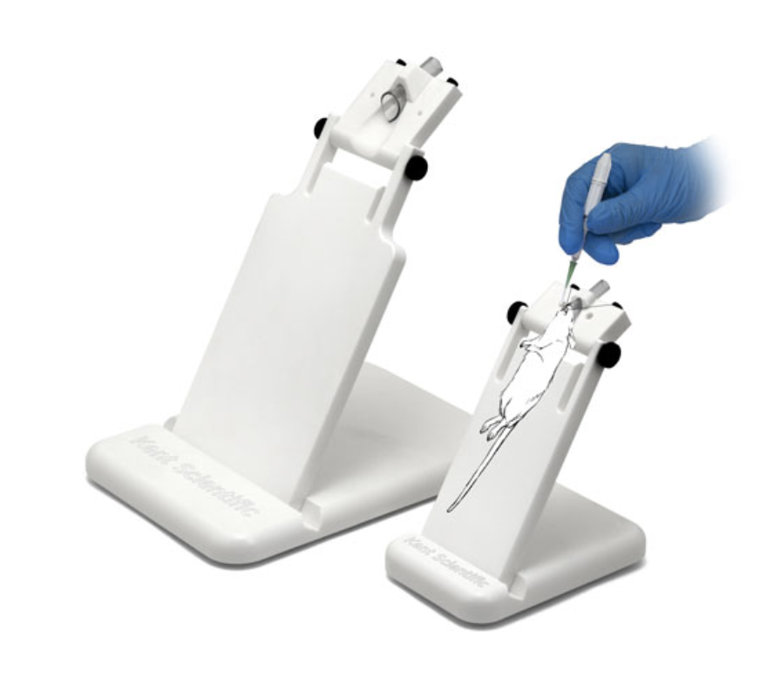

Protocol #2 - Baylor/Rice SATC tissue preparation and imaging

Tissue Preparation for Imaging

1) After euthanasia and removal of the white fat pads and the reproductive organs, the inferior vena cava will be slit below the liver. The left ventricle will be punctured, and the animal injected with 20 ml of cold PBS through the bloodstream.

2) Remove the organ or tissue sample from the euthanized mouse and remove extraneous material.

3) Remove a small section and freeze immediately in liquid nitrogen for molecular analyses.

4) Place organ in 10 ml of freshly-prepared 4% paraformaldehyde in a 20 ml vial.

5) Incubate for 20 - 24 hours at 4˚C with gentle agitation.

6) Remove paraformaldehyde solution and replace with 30% sucrose in PBS.

7) Incubate for 20 - 24 hours at 4˚C with gentle agitation.

8) Embed tissues in OCT, marking orientation for sectioning.

9) Freeze at -80˚C.

Sectioning and Imaging

1) Section frozen tissue blocks at 14 microns, and place three non-consecutive sections on one slide.

3) For each tissue, one slide will be mounted with DAPI stain and imaged on a Zeiss Axio Scan.Z1 scanner, using the 20X objective and Cy5 (for tdTomato) and DAPI fluorescent filters.

4) For the liver, spleen, and target tissue of interest, one slide will be prepared for H&E staining to assess histopathology and immune infiltration.

Analysis

1) Examine images using ZEN software. Note:
a) Presence or absence of tdTomato signal and other fluorescent signals
b) Structural integrity of organ, based on DAPI staining
c) attempt to identify type of cell expressing tdTomato or other fluorescent signals
d) attempt to identify a pattern of tdTomato expression or other fluorescent signals

2) Quantify extent of tdTomato fluorescence using ImageJ
a) Count nuclei using Threshold/Binarize/Watershed algorithms
b) Count fluorescent positive cells, either manually, or using Threshold/Binarize/Watershed algorithms
c) Report data as percentage of positive cells per nuclei

Protocol #3 - Lung inflation/Fixation

- Dissect mice

- Inflate the lung with PFA using a 23G needle through the tracheal

- Dissect the lung

- Cut the lung lobes

Ref: Time-lapse Imaging of Alveologenesis in Mouse Precision-cut Lung Slices. 10.21769/BioProtoc.3403
