JAX/UMass SCGE Protocol for mTmG reporter mice

All aliquot tubes are marked with the volume they contain, the concentration of the RNP, and the number of mice to be injected. The tubes are marked with red dot for the test article (mTmG C20/T2) and black dot for the control RNP (DNMT1 RNP). There are 2 extra aliquots for quality control (QC) for each RNP complex, in addition to 2 aliquots of 1x PBS for QC along with additional tubes of PBS that can be used as a negative control if needed. [Note: Our plan does not include using PBS with a cohort of animals.] The table below summarizes the content of the aliquots shipped to the address:
Murray Lab, B50- 1180
The Jackson Laboratory
600 Main St
Bar Harbor, ME 04609

Mice injections:

- Take the RNP aliquot from the freezer and keep on ice until ready to use.
Let the RNP to warm at room temperature before injection (this can be done by loading the syringe first, while preparing the mice for the surgery).
- The mice are anesthetized with isofluorane to effect (1-3%) and systemic analgesia (Carprofen 10-20 mg/kg) administered according to JAX routine procedure for intracranial injections to brain.
- IS injection coordinate are: ML +/- 2.0 mm
AP +1.0 mm
DV -3.0 mm
- Speed of injections is: 500 nL/min (to a 2 uL total injection) and wait 2 min post injection. Perform injections on both sides of the brain.
- Mice are monitored and provided with supportive care post surgery (heating pad and/or heat light) and monitored continually immediately after the surgery as well as daily for at least 3 days to ensure proper recovery and wound healing of the incision.
- The mice are sacrificed 14 days post injection.
Mice dissections:
  - Mice are euthanized via CO2
- Perfuse the mice with 1XPBS pH 7.4
- Collect the brains and off target tissue panel
- Fix in cold 4% PFA for 4 hours (off target tissues) 48 hours for brain at 4ºC. (Important, no ethanol)
- Wash tissues 2 x with cold 1xPBS pH 7.4, 5-10 min per wash.
- Equilibrate off-target tissues in 30% sucrose/1xPBS with gentle shaking overnight at 4C. Equilibrate brains for 48 hours in 30% sucrose at 4C, until brains are settled at the bottom of the collection vials.
- For off target tisseus, prune away excess connective tissue and fat, embed and freeze in OCT media on dry ice. Store blocks at -80C until ready to section.
- For Brain, affix brain to sectioning chuck of cryostat (cerebellum portion down) using OCT. Cover brain with crushed dry ice until frozen. Move to cryostat and trim brain to striatum area. Collect striatum sections serially (40 um thick) into 24 well plate, 5 sections per well (coronal sections) until striatum is fully collected.
- Stain floating slices using IHC for GFP

4% Paraformaldehyde preparation:
Dilute 16% PFA or 32% PFA (EM grade) to 4% using neutral pH 1x PBS solution. Diluted PFA can be kept and used for up to 1 week.

Immunohistochemistry for GFP
Following Vectastain Elite ABC Kit
Day 1:
- Cut 40 µm sections with cryostat and store floating in cryoprotectant media at -20C (24 well plate) until use.
- Wash off cryoprotectant media with 3 x 5 min washes in 1XPBS (Gibco, pH 7.2), using P1000 to add and draw off liquids
- Wash each well with 500µL 3% hydrogen peroxide for exactly 3 minutes. (stock is 30%)
*Dilute wells with 1X PBS after timer goes off before starting to remove hydrogen peroxide.
- Wash with 1XPBS 2 times for 5 minutes
- Prepare 1.5% goat serum blocking solution: add 3 drops (150µL) of Normal Goat Serum (Vector labs #S-1000) to 10mL of 1X PBS.
  - Add 500µL per well and block sections for at least 1 hour at room temperature. (It is better to do 3-4 hours of blocking if you have time)
- Wash with 1X PBS 3 times for 5 minutes. Leave blocker on (-) controls
- Prepare primary antibody (anti-GFP Thermo/Invitrogen G10362), add 500µL per well and incubate at room temperature for 5 minutes and overnight at 4⁰C (Do no tadd primary ab to negative control well, leave in blocking solution):
Normal Goat Serum (3 drops or 150µL in 10 mL 1X PBS)
1:1,000 dilution GFP primary antibody

Day 2:
- Wash with 1X PBS 2 times for 5 minutes
- Prepare ABC Reagent (Vector Labs VECTASTAIN Elite ABC Kit, Perixodase standard cat. #PK-6100): Add 2 drops of Reagent A to 5mL 1X PBS, then add 2 drops of Reagent B. Gently mix and let stand for 30 minutes before use.
- Prepare secondary antibody, add 500µL per well and incubate at room temperature for 10 minutes
Normal Goat Serum (3 drops or 150µL in 10 mL 1X PBS)
Biotinylated anti-rabbit IgG secondary antibody (Vector Labs Goat Anti-Rabbit IgG Biotinylated Cat. #BA-1000) (1 drop or 50µL in 10mL)
- Wash with 1X PBS 2 times for 5 minutes
- Add 500µL per well ABC Reagent and incubate on shaker at room temperature for 5 minutes.
- Wash with 1X PBS 2 times for 5 minutes
- Stain with 1XDAB (Thermo Metal Enhanced DAB Substrate Kit cat. #34065) for exactly 2 minutes at room temperature, 500µL per well.
10X DAB (stock) in Stable Peroxide Buffer (NOT PBS)
*Dilute wells with 1X PBS before starting to remove DAB to avoid over staining later wells.
- Wash with 1X PBS 3 times for 5 minutes
- Mount on slides: use petridish with diH20, move sections into petridish and carefully move sections onto slides. After adding all sections in the correct layout, goto step 17. NOTE: Do not mount sections that do not contain DAB signal!
- Completely dry sections, mount with permount in fume hood. Let cure overnight. (Alternative: Dry overnight or until completely dry, coverslip using Cytoseal.
**
Day 3:
- Carefully remove excess permouse and clean slides using Xyelene or Windex (without ammonium).
- Submit slides for imaging.

*All incubations and 5 minute washes should be on rocker at room temperature unless stated otherwise.
** MISSING directions for hematoxylin staining (JAX had to go back and unmount slides, rehydrate, stain with hematoxylin, then remount and image)

Materials:
- Normal goat serum: Vector labs S-1000
- Rabbit Anti-GFP Recombinant Monoclonal Antibody: Thermo/Invitrogen G10362
- Goat Anti-Rabbit IgG Biotinylated: Vector Labs BA-1000
- VECTASTAIN Elite ABC Kit, Perixodase (standard): Vector Labs PK-6100
- Metal Enhanced DAB Substrate Kit: ThermoFisher 34065
- Gelatin: Sigma G-1890, Type A from Porcine Skin

Example of tile images: mTmG-C20/T2, 100 µM, 3 µl bilateral IS injections
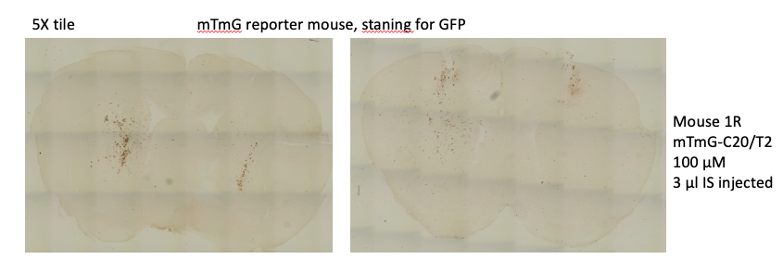
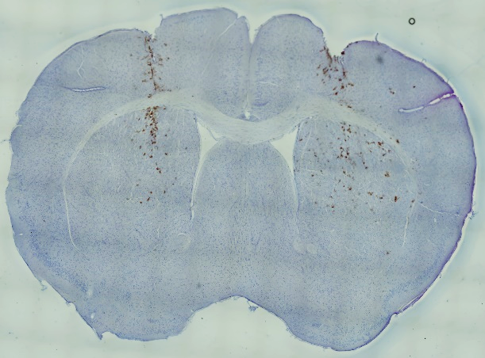
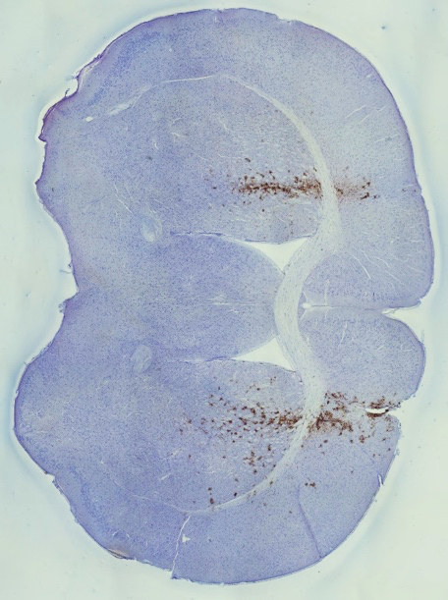
5X

Mouse 1R

Mouse 1N

