Rhesus Monkey Instillation Protocol – STUDY 1
STUDY 1: Delivery of a fluorescent cargo (DRI-NLS-Cy5) + peptide (n=2 animals) to evaluate biodistribution of the fluorescent protein
- Prepare the DRI-NLS-Cy5 Instillation Solution:
  - Thaw DRI-NLS-Cy5 and Shuttle FS66d2(S10) on ice.
  - Prepare the Instillation Solution by adding the components in the order listed (critical) in the table separately for Monkey #1 and Monkey #2. Mix with P1000 pipette tip, avoid forming bubbles, do not vortex. Warm up to RT for 30 min before instillation, and use no later than 4 hours after preparation.

Monkey #1:
Component | Volume (µL)
DPBS | 836
Shuttle FS66d2 (S10) | 176
DRI-NLS-Cy5 | 88
Total Volume “Instillation Solution” | 1,100
Monkey #2:
Component | Volume (µL)
DPBS | 1,012
DRI-NLS-Cy5 | 88
Total Volume “Instillation Solution” | 1,100

Monkey #7:
Component | Volume (µL)
DPBS | 880
Shuttle FS66d2 (S10) | 176
DRI-NLS-Cy5 | 44
Total Volume “Instillation Solution” | 1,100
Monkey #8:
Component | Volume (µL)
DPBS | 1,056
DRI-NLS-Cy5 | 44
Total Volume “Instillation Solution” | 1,100

- Sedate the animals as per established protocol (animals #1 and #2 approximately 3 months of age; animals #7 and #8 approximately 5 months of age; total n=4).
- Collect the bodyweight, body temperature, and respiration rate.
- Place the animal in a dorsal recumbency on a procedure table and intubate the trachea as per established protocol.
- Remove the atomizer from the original sealed pouch and insert it into the trachea so that the atomizer’s tip is positioned below the cricoid cartilage and at least 1 cm above the bifurcation.
- Pre-fill 1,000 ul of the instillation solution into 1 ml syringe.
- Connect the pre-filled 1 ml syringe to the proximal end of the atomizer.
- CT scan prior to instillation if possible.
- Instill the Instillation Solution by placing a fast and firm pressure on the syringe pestle. (Instillation as fast as possible is needed to generate an aerosol from the atomizer’s tip).
- While keeping the atomizer in place in the trachea, disconnect the emptied syringe, connect a new 1 ml syringe pre-filled with 400 ul of ambient air, and expel the air by placing fast and firm pressure on the syringe pestle in the same manner as in previous point. (This will empty the instillation solution trapped in the dead space of the atomizer’s tubing, which is about 230 ul).
- Remove the atomizer and intra-tracheal canula, if any.
- CT scan post instillation if possible.
- Continue anesthesia for additional one hour (animals #1 and #2) or 2 hours (animals #7 and #8) as per established protocol.
- Tissue collection.

TISSUE COLLECTION PROTOCOL
Organ collection after delivery of a fluorescent cargo.
- Open the chest cavity and allow the lungs to collapse.
- Cut the large vessels at the level of diaphragm.
- Perfusion of lung vasculature: Perfuse the vasculature of the lungs with PBS: use a 50 mL syringe with a 20 - 22 G needle to inject between 20 - 100 ml of 1X PBS (more if needed) with 10U/mL Heparin into the right ventricle of the heart until the lungs are pale (or nearly white).
- Cut the trachea as proximally as possible; remove the lungs en bloc (with the heart) from the chest cavity.
- Cut off the proximal about ½ of the length of the trachea and set on ice to be shipped fresh to the UI. Leave enough length of the trachea with the lungs in order to insert and secure the tubing for step 7 and 8. (This fresh tissue will be used for DNA isolation from airway brushing as a negative control for Study 2.)
- Removal of the left lower lobe and shipping the fresh lobe on ice to the UI.
This fresh tissue will be used for DNA isolation as a negative control for Study 2. Using a surgical thread tie off the left lower lobe at the proximal end of the mainstem bronchus and cut below the tie. The purpose of the tie is to stay in place on the remaining lungs and seal off the airway preventing leaking of a fixative that will be instilled in the remaining lung. Place on ice to be shipped fresh to the UI.
- Washing the lungs with PBS to remove unbound fluorescent peptide (only animals #7 and #8).
Using the syringe-tubing setup depicted on Figure 1, fill the syringe with PBS, insert the tubing into the trachea, secure lightly by tying the thread (suture) around the circumference of the trachea with the inserted tubing to create a seal, and allow PBS to flow by gravity into the lungs. Once the flow slows down/stops (a minute or so), remove the tubing from the trachea a allow the washing solution to leak freely out of the lungs. May position the lungs at an angle with the trachea pointing down in order to facilitate the washing liquid free outflow out of the trachea.
- Fixation of the remaining lung. (See Figure 1 below).
Using the syringe-tubing setup used for PBS wash, remove PBS, fill the syringe and tubing with 4% freshly prepared paraformaldehyde and proceed with fixation.
Insert a flexible plastic tubing of an appropriate diameter into the trachea (the tubing of various diameters was provided by the UI). Secure the tubing in the trachea by tying the thread (suture) around the circumference of the trachea with the inserted tubing to create a seal. The tubing (about 35-40 cm) is connected to a 50 ml syringe without a plunger and filled with 4% freshly prepared paraformaldehyde (in PBS), and affixed elevated at 30 cm above the trachea level. Use a two-way or three-way stop valve (provided by the UI) between the syringe and the tubing to regulate the flow of paraformaldehyde (Figure 1).
- Let the 4% paraformaldehyde freely (by gravity) flow into the lungs until the flow stops or nearly stops, and all the lobes have inflated. If needed, refill the 4% PF in the syringe by pouring from top (Figure 1). If the lobes are not inflating, reposition the inserted part of the tubing in the trachea by gently manipulating it, without pulling it out.
- Tie off the trachea while removing the tubing at the same time to keep the paraformaldehyde from leaking out. Let the infused lungs sit in place (in the chest cavity) for 10 min at room temperature.
- Place the lungs en bloc with the heart in a container with allowable volume of 4% paraformaldehyde and ship to UI on cold packs.
- Ship on cold packs overnight to the University of Iowa (shipping address below) as per established guidelines.
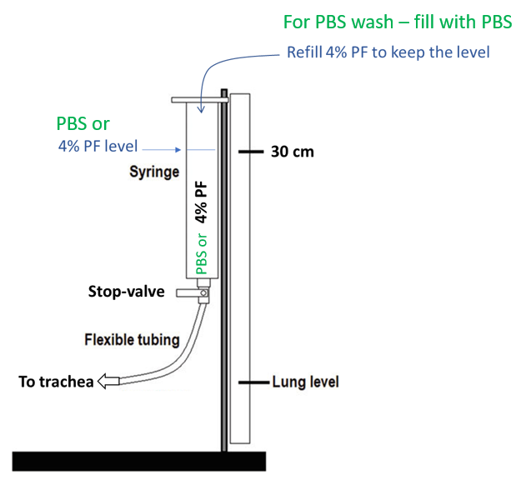
Figure 1. Schematic of a syringe-tubing setup for the lung wash with PBS and perfusion with 4% paraformaldehyde (PF).

University of Iowa shipping address:

McCray Laboratory
Attn: Katarina Kulhankova
6320 PBDB
169 Newton Rd
Pappajohn Biomedical Institute
Carver College of Medicine
University of Iowa
Iowa City, IA 52242
Email: katarina-kulhankova@uiowa.edu
24-hour phone numbers: (319) 855-8541

Analysis of Delivery Efficiency in vivo

Prior to euthanasia the clinical parameters and blood was collected. Following euthanasia, the chest cavity was opened, the large vessels were cut at the diaphragm, and the lung vasculature was perfused with PBS and 10 U/ml Heparin via the right heart ventricle.

The animals instilled with the fluorescent cargo were processed as follows: The lungs of the animals #7, and 8 (Condition #7 and 8) (lower concentration of the fluorescent cargo), were lavage once with PBS by a gravity perfusion to remove any remaining instillation solution. The lungs of the animals #1 and 2 (Condition #1 and 2) (instilled with the higher concentration of the fluorescent cargo) were not lavaged. Lungs and heart were removed en bloc from the chest cavity, the left lower lobe was tied off with a suture at the main lobar bronchus, separated below the suture, and the fresh tissue was placed on ice for shipment to the UI. The trachea was intubated with a PE tubing with a three-way stop valve connected to a 50 ml syringe without a plunger prefilled with 4% PF, tied off to create a seal, and the lungs were inflated in situ with the fixative under the gravity of 30 cm water column. After 10 minutes, the tubing was pulled out while trachea was tied off, and the lungs were placed into a container with 4% PF. The fixative-infused lungs and the fresh lobe were shipped chilled to the UI. Upon receipt, the fresh left lower lobe was used to collect the airway epithelia brushing from the main lobar airway. The 1 mm-diameter cytological brush (…) was inserted into the main lobar airway and brushing was performed by gently rotating the brush several times. Brushing was then collected to 5 ml of PBS in a 15 ml conical by mechanically agitating and swirling the brush to wash off the epithelia. The brushing was centrifuged at 200xG and the pellet was reconstituted in 90 µl of PBS. 40 microliters of the pellet suspension was used for DNA extraction by QuickExtract, 40 µl for flow cytometry, and 10 ul for the cytospin preparation, DiffQuick stain and light microscopy. The fixed lungs were placed into 1 liter of 4% PF for 48 hrs, and then processed through the sucrose gradient with 15% and 30% sucrose in PBS for 48 hrs each. The lobes were serially dissected in smaller pieces, and alternate sections were embedded in OCT for cryosectioning and immunostaining, or in paraffin for sectioning and H&E staining.

Cryosections (10 µm thick) were rehydrated in PBS, permeabilized with 0.1% TritonX, and blocked with Superblock (Ref 37515, Thermo Scientific) and 10% animal sera of a species in which the secondary antibody was raised. Primary antibodies diluted in the staining buffer (PBS, 1% BSA, 0.1% TritonX) at 1:50 – 1:100 dilution was incubated overnight at 4°C in a humidified chamber, followed by a repeated washing. Secondary fluorophore-conjugated antibodies at 1:500 – 1:1,000 were incubated for 60-120 min at room temperature in a humidified chamber, followed by a repeated washing. The coverslips were mounted with Cytoseal containing DAPI and slides were imaged by an epifluorescence (Keyence) or confocal microscopy (Zeiss 710). Where applicable, 1 µm optical z-sections were collected. Image overlays and composites were prepared using FIJI (ImageJ, NIH). Nuclear localization of Cy5-DRI-NLS or a co-localization of Cy5-DRI-NLS with specific cell types of interest was examined under high magnification (40x and 63x objective).
The following staining antibodies were used for immunostaining: CCSP, 07-623, EMD; CK5, 905501, BioLegend; SPC, PA5-71680, Invitrogen; AcTub, T6793, Sigma-Aldrich.

