**Gong Study Protocol**

The goal of this project is to validate the delivery of gene editing components to the mouse brain using a novel type of Nanocage developed by the research team at University of Wisconsin, led by Dr. Shaoqin (Sarah) Gong. This novel nanocage/particle uses a unique thin biodegradable polymer coating surrounding the CRISRP/Cas9 protein editing complex that enables both cellular internalization via the endosome but also endosome escape that greatly improves gene editing efficiency in the target cells. For this study, we will detect editing activity and efficiency through the use of a fluorescent reporter strain, Ai14 (stock number 007914, B6.Cg-Gt(ROSA)26Sortm14(CAG-tdTomato)Hze/J, that will activate a red fluorescent protein (tdTomato) following inactivation of the upstream LoxP flanked stop cassette in the reporter allele. We will analyze the red fluorescent signal in a standard panel of fixed, cryoprotected, frozen and cryosectioned tissues. This analysis will generate data on the presence or absence of signal for the target tissue and cell types (brain, neural cell types) and off target tissue activity (e.g., liver, kidneys, ovary/testes, etc.).

Eighteen mice of both sexes of strain Ai14 (007914) at 8-16 weeks of age will be injected using stereotactic surgery for bilateral striatal injection of RNP-loaded nanocages as described in the table below (table 1) and following our routine procedure for brain injection in adult mice. Prior to injection each RNP-loaded nanocage will be tested for contaminants via JAX’s diagnostic lab. One hemisphere will be injected with Ai14-targeting nanocage, the other hemisphere will be injected with negative control RNP loaded nanocage. The target coordinates will be (Fig. 1, the red dot) Ant: + 1.2 mm from bregma and M/L +/- 1.6 mm from midline; Depth = 3.25/3.75 mm. After injection and before retracting the needle, a waiting period of 10 minutes will be lapsed to minimize backflow through the needle tract.

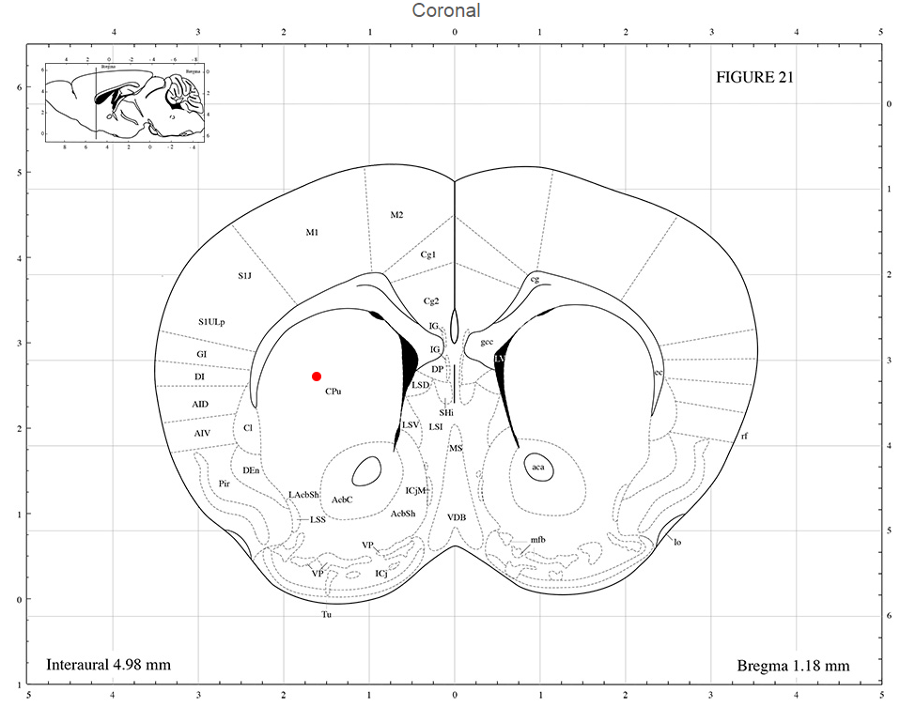

*Figure 1: Screen shot of Paxinos mouse brain atlas depicting target coordinates for intrastriatal injections.*

|  |  |  |  |  |  |  |  |
| --- | --- | --- | --- | --- | --- | --- | --- |
| Study Arm | Route of Administration | Number of mice | Test Article | Injection volume | RNP Conc. | Freq. | Age |
| 1 | Intrastriatal, bilateral | 6 (3M, 3F) | RNP loaded Nanocage #2 (NC-CPP) / Control Nanocage | 1.0 uL @ 0.2 ul/min | 20 uM | 1x | 8 w |
| 2 | Intrastriatal, bilateral | 6 (3M, 3F) | RNP loaded Nanocage #3 (NC-RVG) / Control Nanocage | 1.0 uL @ 0.2 ul/min | 20 uM | 1x | 8 w |
| 3 | Intrastriatal, bilateral | 6 (3M, 3F) | RNP loaded Nanocage #4 (NC-no ligand) / Control Nanocage | 1.0 uL @ 0.2 ul/min | 20 uM | 1x | 8 w |

**Analysis of intracranial injected animals:**

All 18 intracranial injected mice will be euthanized by CO2, followed by transcardiac perfusion with heparinized saline at 14 days post compound/test article(s) administration and a standard panel of tissues (lung, eye, heart, spleen, kidneys, liver, ovary/testes, skeletal muscle, eye, skin, large intestine, small intestine, stomach, lymph node, bladder, epididymis/uterus, and pancreas) will be collected. A portion of each tissue collected (with exception of brain) will be postfixed in 4% PFA at 4C for 24 hrs, cryoprotected in graded sucrose (30% in 1xPBS, 4C), embedded with OCT medium, frozen at -80C and cryosectioned in 10-30um thickness. Brains will be collected, postfixed in 4% PFA for 48 hrs, cryoprotected in graded sucrose (30% sucrose in 1xPBS, 4C) and cryosectioned in 40um thickness. Brains sections containing the mouse striatum will be serially collected in 6-wells plates into cryoprotectant media and stored at -20C until ready for immunostaining and imaging.

**Immunofluorescence Protocol:**

Solutions:

DILUTION MEDIUM

40.0 g NaCl

15.0 g Trizma Base

2.5 ml  (0.05%) TritonX

5.0 L dH2O

DILUTION MEDIUM (1/10 recipe)

4.0 g NaCl

1.50 g Trizma Base

0.25 ml  (0.05%) TritonX

500 mL dH2O

Blocking Solution

95 ml dilution media

5 ml donkey serum

2 g bovine serum albumin (BSA)

Day 1:

* Move all sections from 1 well of the 6 well plate into a new plate containing ~10 ml of Dilution Media.
* Wash tissue (3 x 10 min) in Dilution Media to wash off cryoprotectant, using ~10 ml volume per wash, on rotating platform at 4C. Remove buffer using suction, being careful to add and remove solutions away from tissue samples.
* Blocking step: incubate sections with blocking solution (5% donkey serum, 2% BSA in dilution media) for 2 hours at 4C on rotating platform.
* Primary antibody incubation: move sections to 2.0 ml tubes and add 500 ul of primary antibody mixture and incubate at room temperature overnight, on rotating platform.
  + Dilute all antibodies in blocking solution for incubation. Note: add RFP antibody (1:5000) to blocking solution first, then add in 1:500 GFAP and 1:1000 NeuN
    - RFP – rabbit (dilution 1:5000), # 600401379, Rockland
    - GFAP – rat (dilution 1:500), # 13-0300 , ThermoFisher
    - NeuN – mouse (dilution 1:1000), #ab104224 , Abcam

Day 2:

* Transfer tissues from 2.0 ml tube back to a 6 well plate containing dilution media
* Wash tissues (3 x 10 min) with Dilution Media
* Secondary antibody incubation: each secondary antibody was diluted 1:1000 in 1xPBS and 5ml added to each well after wash buffer was removed. Incubate at room temperature on rocking incubator, protected from light for 2 hours.
* Wash (3 x 10 min) in 1x PBS
* Counterstain nuclei with DAPI, 12 minutes covered
* Wash (3 x 10 min) in 1 xPBS
* Mount brain sections to glass slide (7-8 sections per slide) and carefully flatten to remove folds and wrinkles. Dry sections and mount with minimal amount of Fluor Gel (cat # 17985-10 Electron Microscopy Scince). Cover with mounting medium, allow to set for 5 minutes in dark then apply coverglass.

**Imaging**

Assumptions:

Brain slices are sectioned at 40-um thickness and stained with anti-NeuN, anti-GFAP, and anti-RFP antibodies and DNA is counterstained with Hoechst or DAPI dye.

Images are collected in a 3 step z-stack from confocal microscope at 20x magnification with a total field thickness of 10 um. (middle of the section and 5 um above and 5 um below the central image slice are collected).

ROI area= area of RFP signal drawn around the injection site in which a group of at least 5 cells are positive and are within 135 um of each other.

Image Analysis and Quantification Method:

1. Open image stack in FIJI (4 channels, 3 images per channel)
2. Duplicate RFP channel and
   1. Generate a maximum image projection image (Image> stack> z project)
   2. Adjust the RFP threshold in the max projection image (Image> Adjust> Threshold> Otsu (red))
   3. Convert to binary image (Process> binary >make binary) and save
3. Duplicate GFP channel and
   1. Generate a maximum image projection image (Image> stack> z project)
   2. Adjust the GFP threshold in the max projection image (Image> Adjust> Threshold> Otsu)
   3. Convert to binary image (Process> binary >make binary) and save
4. Count Edited Neurons in ROI area
   1. Draw ROI polygon around RFP positive region in RFP binay max projection image and save ROI- record area of polygon ROI in spreadsheet (add polygon to ROI manager and measure)
   2. Generate overlay image (overlay RFP image onto GFP image with 40% transparency)
   3. Using multipoint tool (with points added to ROI manager) count number of RFP positive cells that overlap GFP positive cells in ROI. Record the results and number of edited cells, save image with ROI. You may need to clear area outside of polygon ROI to enable FIJI to count cells within the ROI.
5. Count total neurons in ROI area
   1. Open Binary GFP max image
   2. Process image using StarDist2D plugin (with fluorescent default settings)
   3. Adjust the threshold of the resulting Label Image (V) from StarDist2D to so that all cells are visible in the image (Image> Adjust> Threshold> Default… manually adjust histogram so that virtually all of the signal is captured by moving the top slider one step to the right, the bottom slider is all the way to the right) (this also serves to convert the image to a binary image)
   4. Process image using watershed tool to separate objects that are touching (Process> binary> watershed)
   5. Clear ROI manager to remove cells counted during StarDist2D processing
   6. Copy ROI from RFP image to the GFP image
      1. From an open image that has the ROI drawn, click on the polygon, then click on the processed GFP image, then choose Edit> Selection> Restore Selection to add the ROI to the current image
   7. Count GFP+ cells within ROI
      1. Either clear area outside of the selection OR click inside the ROI, then select Analyze> Analyze Particles: Size: 40-Infinity; circularity: 0-1, Show outlines, display results, summarize, add to Manager.
      2. Save resulting image and results from ROI manager (count and location)
      3. Record as total number of neurons in ROI
6. Calculate % Edited Neurons in ROI by dividing the number of edited neurons by the total number of neurons and expressing it a fraction of the total (%).